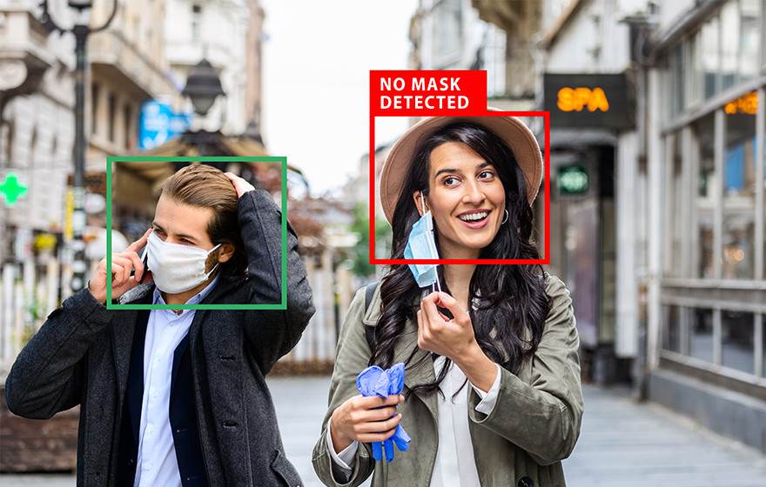

**Article On - Face mask detection Alert system using Artificial Intelligence**

Introduction:

In the new world of coronavirus, multidisciplinary efforts have been organized to slow the spread of the pandemic. The AI community has also been a part of these endeavours. In particular, developments for monitoring social distancing or identifying face masks have made the headlines.

But all this hype and anxiety to show off results as fast as possible, added up to the usual AI overpromising factor, maybe signalling the wrong idea that solving some of these use cases is almost trivial due to the mighty powers of AI.

To paint a more complete picture, we decided to show the creative process behind a solution for a seemingly simple use case in computer vision:

1.   **Detect** people that pass through a security-like camera.

2.   **Identify face mask** usage.

3.   **Collect** reliable **statistics** (% of people wearing masks).

In a nutshell, our system works by performing two main tasks:

1. **Object detection** with a neural network, pre-trained for **face detection**.
   * Output: list of bounding boxes around each detected face.
2. **Classification** in two classes (with/without mask), using another neural net.
   * Output: score from 0 to 1 signifying the probability of a face wearing a mask.

* The whole model is developed using tensor-flow and applied CNN for creating the Face Mask Detector model through which multiple subjects can be checked at the same time.
* Face Mask Detection System uses existing IP and CCTV cameras to look for the faces and detect people without masks.
* Using an AI network, this software can recognize if the person is not wearing / wearing a mask. The software also allows users to add faces and phone numbers to send them a notification if they are not wearing a mask. In case, the face captured by the camera is unrecognized, the notification is sent to the administrator that " One Visitor violated Face Mask Policy. See in the camera to recognize the user. A Person has been detected without a mask."

**Some of the images in the dataset are shown below:**

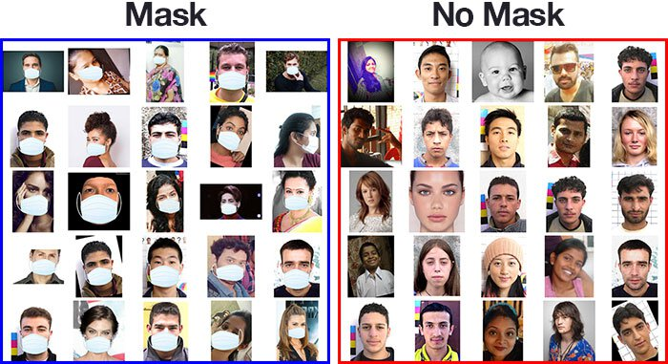

Datasets – [www.kaggle.com](http://www.kaggle.com)

A new challenge / Limitations:

As the problem statement states about detecting face mask, the reality of images obtained from real-world sources like CCTV or surveillance cameras can be much harsher. We focused on this particular camera during most of the development, but we also tested it with other sources.

Can you imagine the main issues that we’ll be facing? To enumerate some:

1. **Size of the images**. Faces are drastically small and much less clear.
2. **Varying angles.** People are rarely looking straight to the camera — they look at every other possible angle.
3. **Lack of clarity.** Often, it’s very difficult — or not possible at all — to tell if the person is wearing a mask or not from a single still frame.

Here are some concrete examples of what our solution is expected to handle:

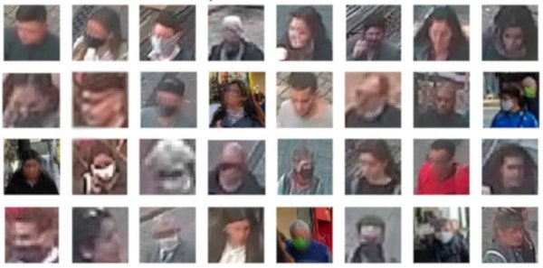

*Sample face images (anonymized) from our dataset. The minimum size is 150x150 pixels, only frontal faces.*

Also, keep in mind that we want to reliably count the fraction of people that are actually wearing masks out of all those that pass by our camera setup.

All of these points have a big impact on the choices made throughout this project and are the reason why many solutions that have appeared on the internet these past few weeks really won’t work in real scenarios like this.

Our approach: Follow trajectories

Step-01

A person appears in front of the Camera / CCTV - The facial detection system gets activated and detects your face.

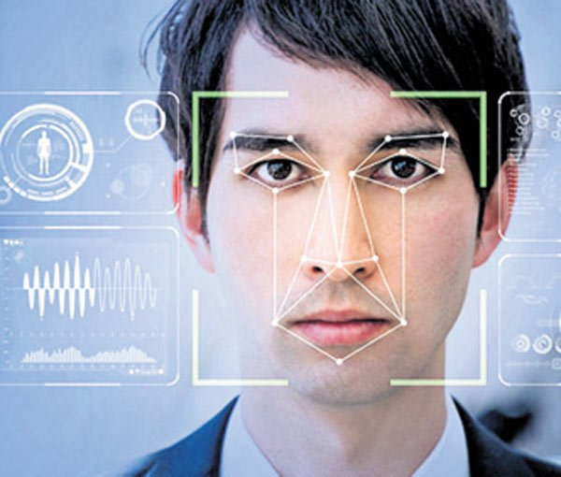

Step-02

After detecting the face from the webcam stream, we are going to save the frames containing the face. Later we will pass these frames(images) to our mask detector classifier to find out if the person is wearing a mask or not.

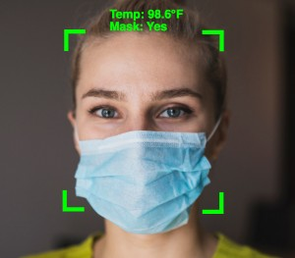

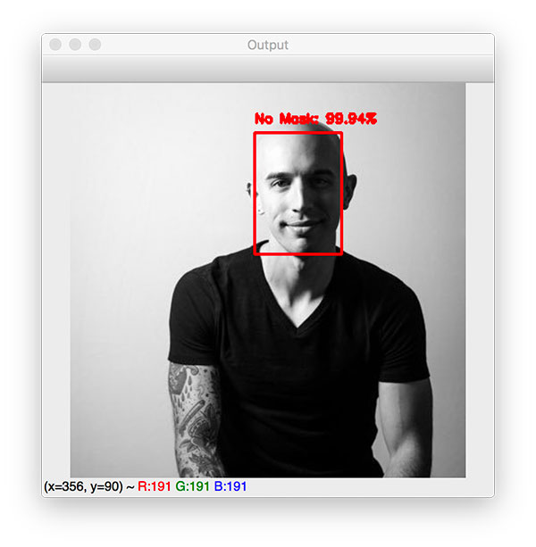

Step-03

If the person is wearing a mask, then he/she will get a Message in terms of the Pop-Up window to highlight that " Access-Granted: Authenticated User ."

If the person is not wearing a mask, then he/she will get a Warning Message in terms of the Pop-Up window to highlight that “Access-Denied: Please wear a Mask."

**Also, the system will trigger an email to the concerned person/authority alerting them that "**One Visitor violated Face Mask Policy. See in the camera to recognize the user. A Person has been detected without a mask."

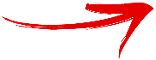

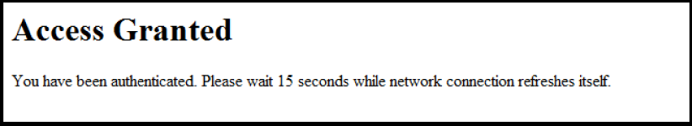



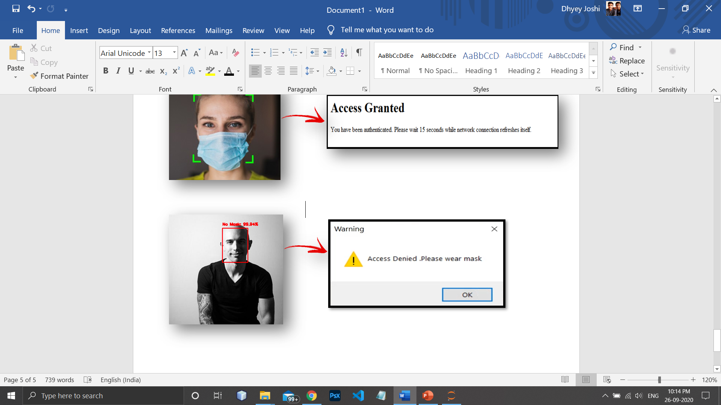



Summary:

As we know the current situation of us all in this COVID-19 pandemic, all of us are stuck in our homes and are not allowed to go out unless its’ an emergency or to do our jobs. Even on going outside, we all have to wear our masks compulsory but the main problem in that is the mindset of certain people who think that not wearing the mask is alright and those people when enter the public places without wearing masks, makes this pandemic disease more vulnerable to others and themselves also. So thinking of this problem ,we have made project based on face mask detection of the people who enters the premises gets their faces scanned and only people wearing the masks are allowed to enter and the people who are not wearing the masks are not given entry and an alert message is sent to the person in authority whenever someone not wearing the masks is detected.

This technique will be very helpful to the security authority people who can just check from the security camera that if the person is wearing the mark or not. There are some limitation as the resolution of the camera could not be good or the face angle sometimes might not be perfect to recognized by the detector. But not only this technique will be helpful in this Covid-19 pandemic only, but it will also be helpful to the hospital authorities where , wearing masks is mandatory not only for the doctors but also for some patients like for the people who have serious lung diseases, etc.